Mean absolute percentage error (MAPE)
Expresses accuracy as a percentage of the error. Because this number is a percentage, it can be easier to understand than the other statistics. For example, if the MAPE is 5, on average, the forecast is off by 5%. The equation is:
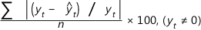
where y_{t} equals the actual value, equals the fitted value, and n equals the number of observations.
Mean absolute deviation (MAD)
Expresses accuracy in the same units as the data, which helps conceptualize the amount of error. Outliers have less of an effect on MAD than on MSD. The equation is:
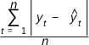
where y_{t} equals the actual value, equals the fitted value, and n equals the number of observations.
Mean squared deviation (MSD)
A commonly-used measure of accuracy of fitted time series values. Outliers have a greater effect on MSD than on MAD. The equation is:
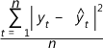
where y_{t} equals the actual value, equals the forecast value, and n equals the number of forecasts.

